Company X CBAM Report
Prepared by: PeerCo, XXX 2024

Reporting Period: XXXX
Invoice Number: xxxxx
Your PO Number: xxxxx

Commodity Code: xxxxx
Commodity details: xxxx

Supplier/Installation: Company X details and facility address

Goods: SPEC of CBAM Goods

Installation Emissions
Installation emissions (total):
Direct embedded emissions: xxxx
Indirect embedded emissions: xx
Total: xxxx

Carbon Linked to CBAM Invoice: xxx

Production Method
Direct Emissions
Explanation of method used in the production process.

Indirect emissions:
Electricity consumed in MWh, emissions factor sourced directly from National Grid, Great Britain grid.

CBAM Product Direct and Indirect Embedded Emissions

System boundaries:
Documentation of the manufacturing ‘system’ linked to the CBAM goods. This needs to remain separate in order to define product carbon and to attribute wider facility carbon emissions to a product.
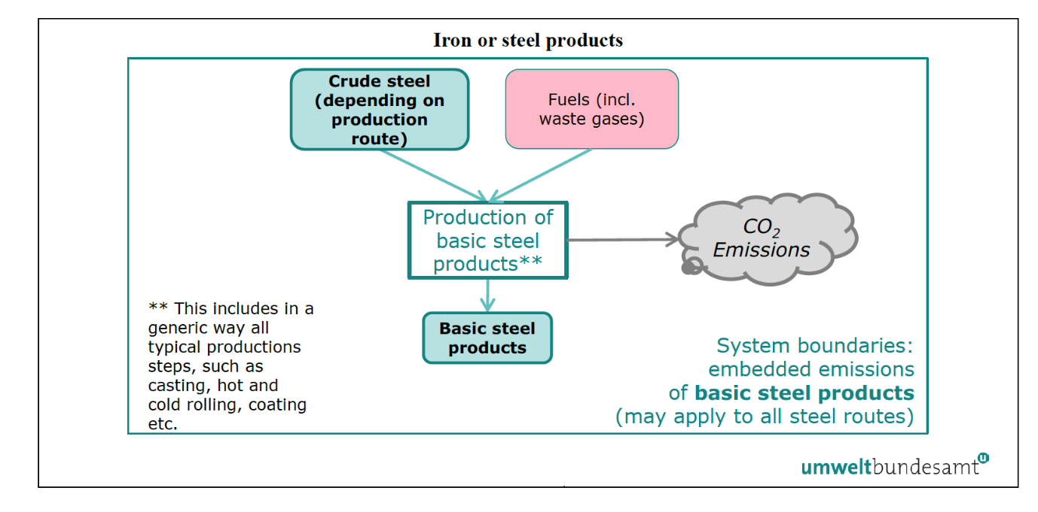
Source: EU Guidance

Precursors Embodied Carbon
Detailed carbon emissions linked to the embodied carbon of all precursors or purchased materials.

Consumption Levels | Activity Data (tonnes) | Carbon Content | Emissions (tCO2e) | Comments
xx | xxx | xxx | xxx | xxx

Default values information if needed due to a lack of precursor data.

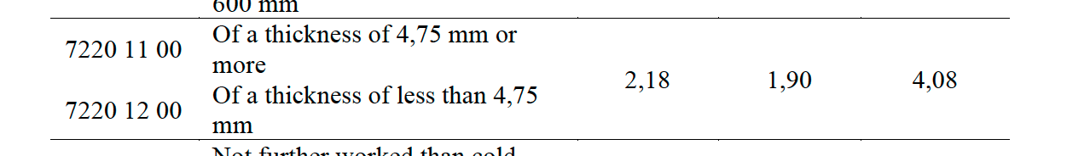

Installation’s Indirect Emissions
All electricity is sourced from the grid.
The Emissions Factor (EF) used s based on hourly, National Grid data and is calculated on XXXX actual hourly use and national grid carbon intensity data. National Grid’s Carbon Intensity API (include link).

- Total electricity consumption for the installation (time period): XXX MWh
- Average emissions factor: XXX kg CO2e per MWh (PeerCo calculation)
- Composition of emissions factor: XXXX
- Total indirect emissions: XXX
- Waste gases/onsite renewables – additional information XXXX

Installation Activity Levels: Time Period Q2 2024

Products | Activity Data and Level | Units
Precursor | XXX | tonnes
Quantity of Goods Produced | XXX | tonnes
Internal Scrap | XXX | tonnes

Total Carbon Emissions: Q2 2024

Total amount of goods produced | XXX | Tonnes for Q2
Total direct emissions of the production process for steel products | XXX | t(CO2e)
Total indirect emissions of the installation | XXX | t(CO2e)
Total CO2 per tonne production | XX | t(CO2e)
CBAM tonnes produced | XXX | t(CO2e)
CBAM direct emissions | XXX | t(CO2e)
CBAM indirect emissions | XXX | t(CO2e)
Total CBAM Emissions | XXX | t(CO2e)

